MD.070 Application Extension Technical Design

Invoice Scanning

Author: Dale
Creation Date: February 5, 2014
Last Updated: March 3, 2015
Document Ref: MD070_
Version: DRAFT 1A

Title, Subject, Last Updated Date, Reference Number, and Version are marked by a Word Bookmark so that they can be easily reproduced in the header and footer of documents. When you change any of these values, be careful not to accidentally delete the bookmark. You can make bookmarks visible by selecting Tools->Options…View and checking the Bookmarks option in the Show region.

Approvals:
To add additional approval lines, press [Tab] from the last cell in the table above.
You can delete any elements of this cover page that you do not need for your document. For example, Copy Number is only required if this is a controlled document and you need to track each copy that you distribute.

Document Control

Change Record
3
Date | Author | Version | Change Reference
5-Feb-14 | Dale Poulter | Draft 1a | No Previous Document

Reviewers

Name | Position

Distribution

Copy No. | Name | Location
 | Library Master | Project Library
 |  | Project Manager
The copy numbers referenced above should be written into the Copy Number space on the cover of each distributed copy. If the document is not controlled, you can delete this table, the Note To Holders, and the Copy Number label from the cover page.

Note To Holders:
If you receive an electronic copy of this document and print it out, please write your name on the equivalent of the cover page, for document control purposes.
If you receive a hard copy of this document, please write your name on the front cover, for document control purposes.
Contents
Document Control ii
Technical Overview 1
Solution Overview 1
Modules 1
Application Setup 2
Form Personalisation 2
Form Functions 8
Profile Options 10
Application Express - Scanned Invoice Image Management 12
Page 1 12
Concurrent Program –Create Invoice Batch 13
Executable 13
Concurrent Program 13
Java Source 14
DirList 14
PLSQL Packages 15
GET_DIR_LIST 15
Database Design 16
Tables 16
Sequences 16
Public Synonyms 16
Packages and Procedures 17
Installation Instructions 18
Components 18
Installation Steps 18
Open and Closed Issues for this Deliverable 19
Open Issues 19
Closed Issues 19

To update the table of contents, put the cursor anywhere in the table and press [F9]. To change the number of levels displayed, select the menu option Insert->Index and Tables, make sure the Table of Contents tab is active, and change the Number of Levels to a new value.

Technical Overview
This document describes the updates required to the technical components to implement the customization, Invoice Scanning.

Solution Overview

Modules

Concurrent Program
The following concurrent programs were created to support Invoice Scanning.
Create Invoice Batch

Application Express
The following Apex applications were created to support Invoice Scanning.
Scanned Invoice Image Management

Application Setup

Form Personalisation
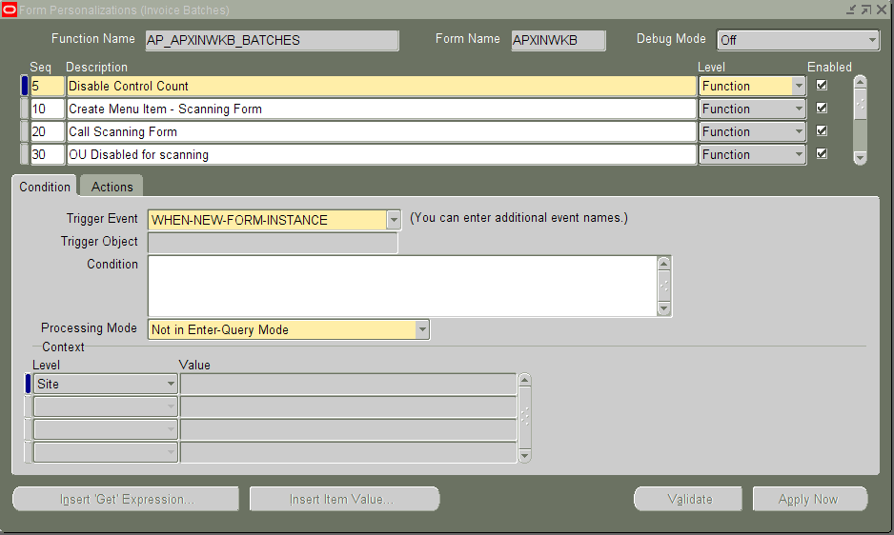

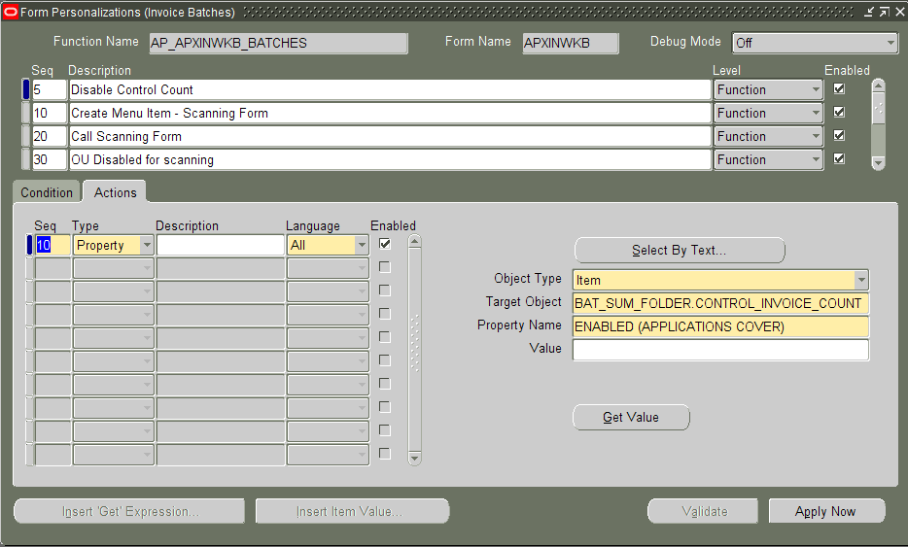

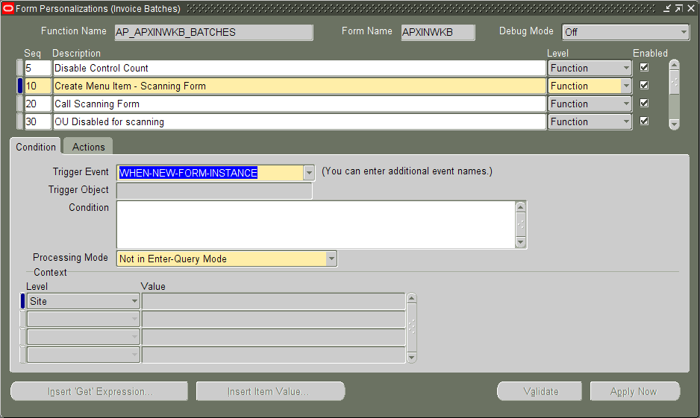

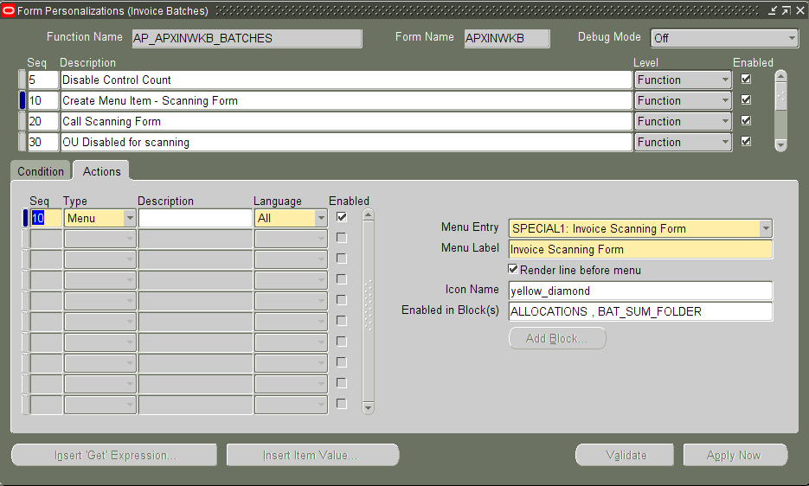

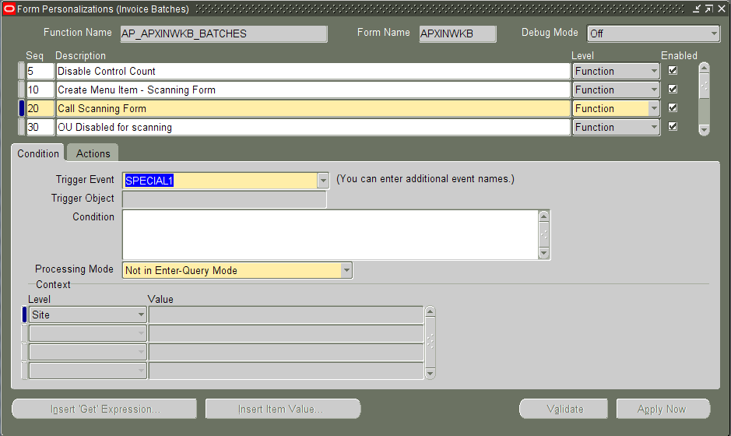

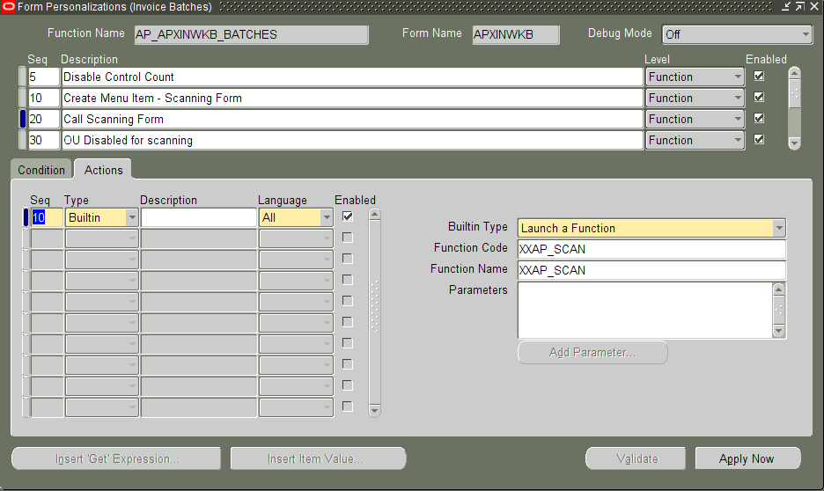

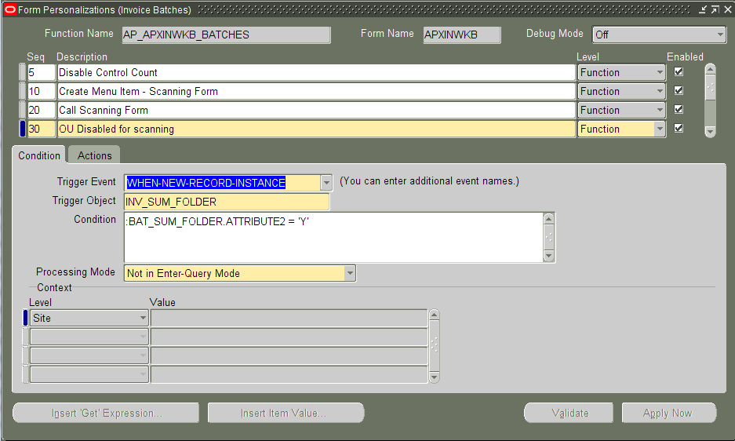

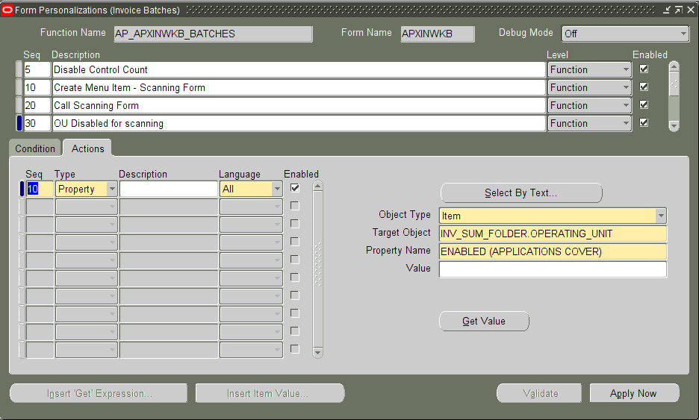

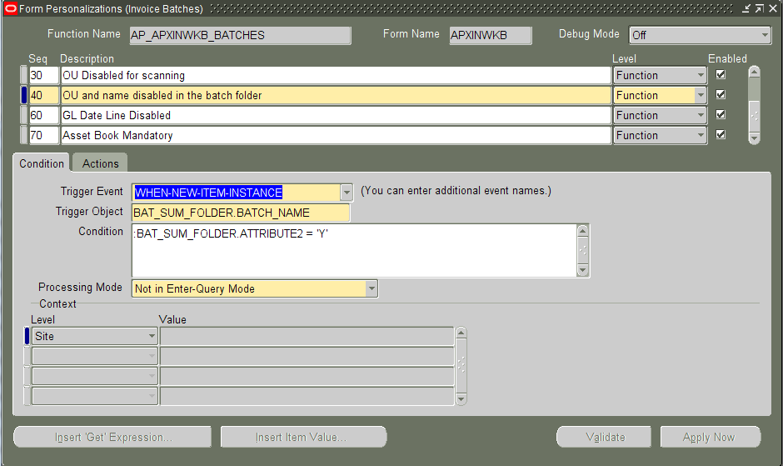

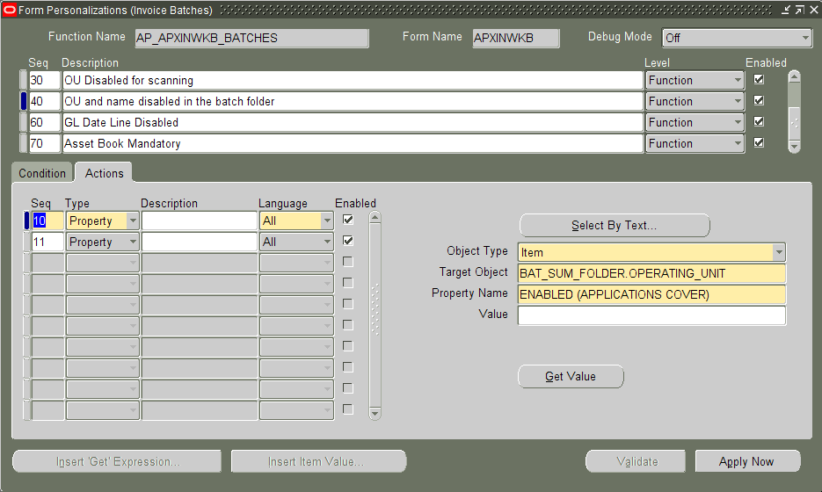

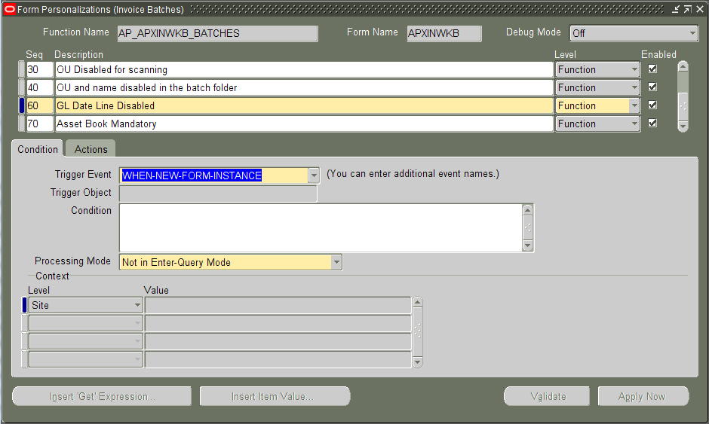

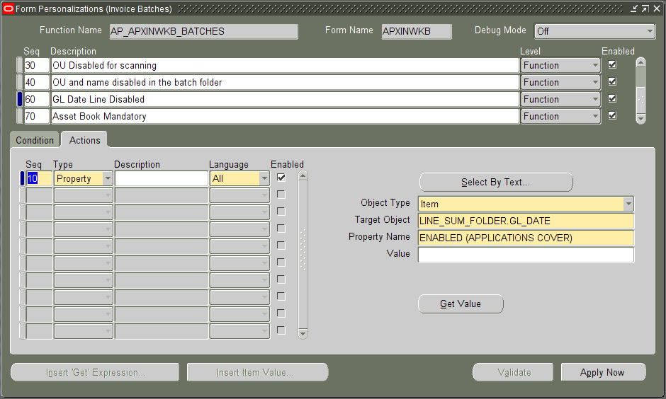

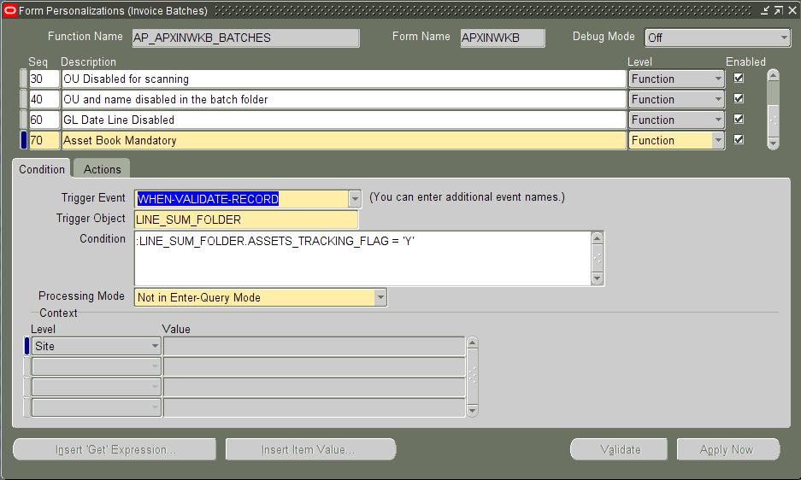

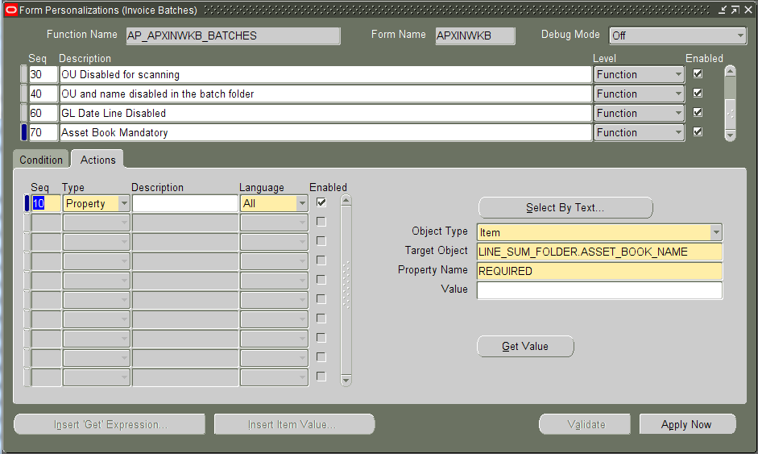

Form Functions
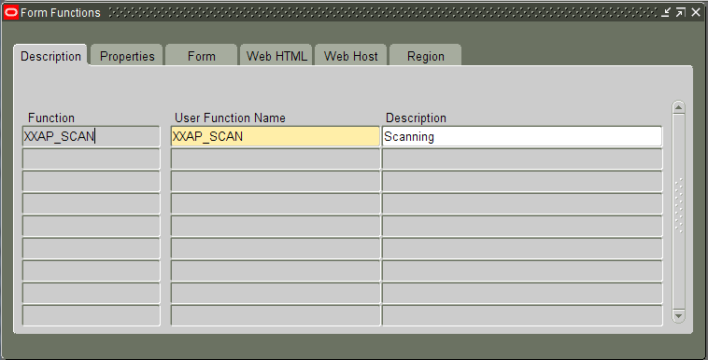

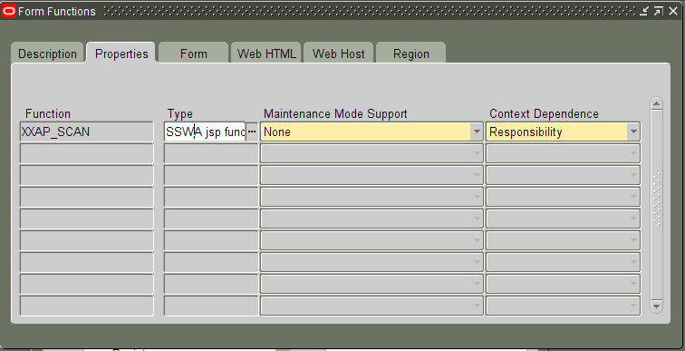

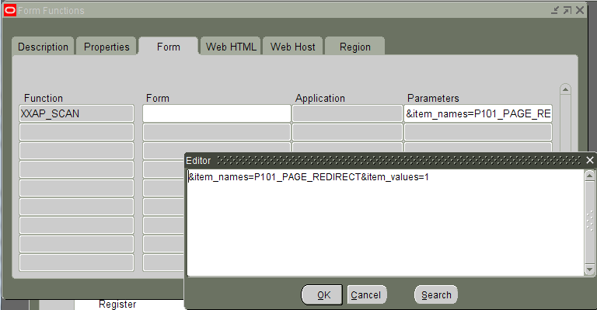

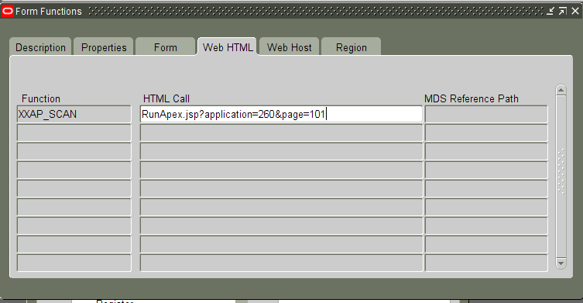

Profile Options
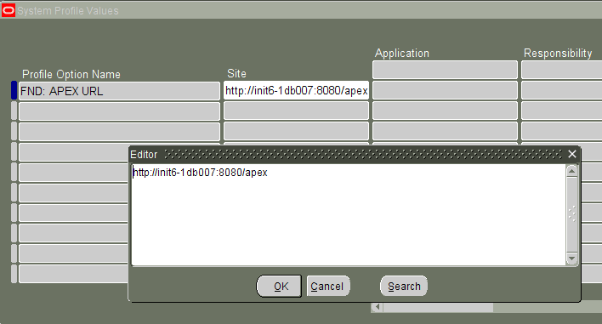

Application Express - Scanned Invoice Image Management

Page 1
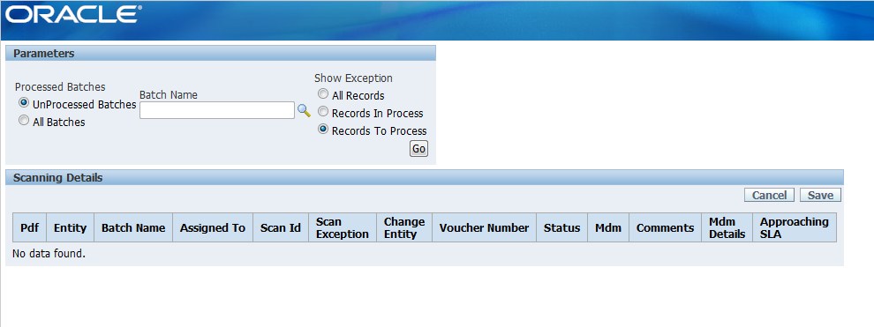

Concurrent Program –Create Invoice Batch

Executable
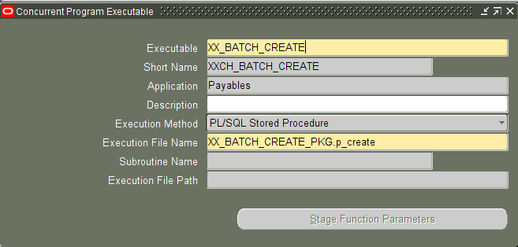

Concurrent Program

Java Source

DirList
import java.io.*;
import java.sql.*;
public class DirList
{
public static void getList(String directory)
throws SQLException
{
File path = new File( directory );
String[] list = path.list();
String element;
for(int i = 0; i < list.length; i++)
{
element = list[i];
#sql { INSERT INTO XX_AP_SCAN_DIR_LIST (FILENAME)
VALUES (:element) };
}
}
}

PLSQL Packages

GET_DIR_LIST
create or replace PROCEDURE "GET_DIR_LIST" (
p_directory IN VARCHAR2 )
AS
language java name 'DirList.getList( java.lang.String )';

Database Design
This section summarized new and changed database objects and data required to support Invoice Scanning.

Tables

Column | Description | DataType | Null Allowed

Sequences
Sequence Name | Start With

Public Synonyms
Synonym Name | Synonym Schema | Database Object | Object Schema

Packages and Procedures
Invoice Processing contains the following PLSQL packages:

contains the following functions and procedures:

Installation Instructions

Components

SQL Scripts

PL/SQL Packages

Workflow Definitions

FNDLOAD scripts

Installation Steps
- Run scripts in SQL plus with APPS user:
- Load concurrent program using FNDLOAD:
Add to or modify this list as appropriate. Provide additional details where necessary to facilitate the creation of the installation routines.
Indicate the specific menu options added to access new forms.

Open and Closed Issues for this Deliverable
Add open issues that you identify while writing or reviewing this document to the open issues section. As you resolve issues, move them to the closed issues section and keep the issue ID the same. Include an explanation of the resolution.
When this deliverable is complete, any open issues should be transferred to the project- or process-level Risk and Issue Log (PJM.CR.040) and managed using a project level Risk and Issue Form (PJM.CR.040). In addition, the open items should remain in the open issues section of this deliverable, but flagged in the resolution column as being transferred.

Open Issues

ID | Issue | Resolution | Responsibility | Target Date | Impact Date

Closed Issues

ID | Issue | Resolution | Responsibility | Target Date | Impact Date

